Alternatives to Worksheets!
What can kids do for seatwork, work boards, and independent time? Here are some ideas!

Think-pair-share and class discussions. What I have found is, if I hand them a post-it note they it.
IE: We were doing fact and opinion and I gave them a pink and green post-it. I told them to read to find one fact (green post-it) and one pink (pink post-it) write it down with their number on it and put it under the heading on the chart paper.
Their number allowed me to assess (check-mark on my clipboard since we are standards based), they got to talk to partners and work together, get up and walk around to put the post it note on and we discussed as a class. The whole thing took 20-25 minutes, no worksheet needed. I took the Post-it and put it in their portfolio for evidence when we were done.

Blank books – they fill them with words, pictures or sentences

Making words/Word Families – use the Word Families book – they use letter tiles or cards to make as many words as they can with a given set of letters and write a list of all the words they make

Graphic Organizers – students read a self-selected book (can be a little leveled reader or a real picture book) and respond in some way – you could have choices of the organizers.

Letter Center- Stock with envelopes, letter templates (to begin with, can be changed to notebook paper once they learn the format of a letter), example of how envelopes should be addressed and a mailbox. Students write a letter to someone in class, the teacher or someone in the building. On Friday the letters are delivered.
Crazy Picture Writing- Laminate “crazy pictures” and students write stories about the pictures and put in class book
Science Table- Put shells, rocks, seeds, dead bugs, anything from “nature” on a table with books about each object. In a notebook, have a “factoid” form that the students fill out about the objects they are researching.
Blog response - to a prompt, have a discussion
Ticket out the Door - summary sentence, give an example, solve a problem, turn in an answer on a notecard, http://www.ideasforeducators.com/1/post/2012/2/a-twist-on-ticket-out-the-door.html
"Twitter" board - post facts/opinions/statements
"Say and Pay"-as kids are leaving the room, kids are given a question, if they get it right, they get $ (not real but our classroom economy $) Like ticket out the door
ipad recording of work process/voice explaining
Write on something else -ipad app like Doodle lite, little white board, on the desk or table with neon Expo markers, mix it up! to show work
construction paper flip books to organize ideas/learning, making books
spelling tests on spelling city.com
Anchoring Activities (do when done, beginning of day, stuck & waiting for help)
- DEAR time (use Excellence in Reading program at www.mensaforkids.org)
- journal/learning log
- vocab development (http://www.superkids.com/aweb/tools/words/wod.shtml; http://www.wordcentral.com/home.html; http://www.merriam-webster.com/word/subscribe.htm)
- math problem of day (on board)
- brain teasers (http://www.internet4classrooms.com/brain_teasers.htm
Bookmarks - http://www.gifted.uconn.edu/semr/Bookmarks.pdf
Be the Teacher: have a student start the class
- bring in quote and run discussion
- recap yesterday’s work
- introduce new vocabulary
- work a homework problem (give heads-up, require no other homework)
- teach a lesson to the class (planned in advance) – THINK LIKE THE ASSESSOR

Games Equate; Boggle, Upwords, 20 Questions, cooperative games, file folders, Frog Games, I have Who has, Around the World

Interest-driven Independent Study Project (kid tested, teacher approved)
elementary: www.gifted.uconn.edu/WebClasses/Interest-A-Lyzer.pdf

Library – read and respond; give list of books (use list at www.mensaforkids.org )
Students demonstrate understanding with one of these ideas:
- 3-Part Harmony written summary:
What happens in the beginning/middle/end?
What is the most critical moment?
How else could the author have ended the story?
- book moment with you
- book box – various items that represent key objects in the story (not a diorama) – give written or oral explanations

Pitch it– pitch the book to a Hollywood producer for a movie (written or oral)

Magazines:
Smithsonian, National Geographic, sports (ESPN, Sports Illustrated for Kids)
Find list of magazines for kids at: http://www.monroe.lib.in.us/childrens/booklists/kidsmags.html
Write a 1-minute summary about what was read.

One-minute Master: write for one minute about the most significant (useful, meaningful, awful, disturbing, effective, helpful) thing they learned. Trade with a partner and respond (agree/disagree/build).

Questions – multiple levels of questions – ask a partner & discuss OR write an answer.
- Use your DOK chart or Critical Thinking Wheel

RSQC2
• In two minutes, students recall and list in rank order the most important ideas from a lesson
• In two more minutes, they summarize those points in a single sentence
• Next, they write one major question they want answered
• After that, they identify a thread or theme to connect this material to the course's major goal
  - Lastly, they comment on how well they feel they learned the information (use smiley/sad faces for younger kids)

TED Talks (www.ted.com)
http://sites.google.com/site/thetedxproject/ - example of using TED in classroom

Tagxedo (www.tagxedo.com) - word clouds
Vocabulary: FRAYER MODEL:
Definition (in own words) Draw a picture
Examples (from own life) Non-examples (from own life)
Writer’s Antithesis:
Students take a passage from the text they are reading and rewrite the passage reversing one or more of the writer’s choices: the tone, characterization, writer’s voice, point of view, setting, etc.

You Own the Word:
- individualized spelling list:
- word art
- illustrated dictionary
- acrostic poems

Flip charts – with ActivBoard
Write questions and quiz each other
Powerpoint projects for science & social studies topics

Versatiles

Readers’ notebooks – write letters to your teacher about what you are reading and learning – with reflection – making connections

Poetry books with illustrations

Start your own comic strip applying standards you have learned – any subject

Partner games - math

Create a dance/song/rap to teach a standard/element

Write a skit/play/proverb to teach a standard/element

Create your own figurative language book with illustrations

Design an experiment – use the scientific method – have peers perform experiment

Propose a debate about something you believe in (upon any lesson reflection) – now argue the opposing side

Create a game to teach a standard – teach it to your peers

Design a bridge, build it, test its strength – what have you discovered?, now revise and improve your design (design a paper airplane – same drill)

Computer based group research – solve a problem or go on a fact finding mission

Math Class Story Problems: Write your own story problem place it in a class book and have others solve it.

Webquests: Link them to your class website and have students work as a team to solve the quests.(works great with science)
Photo Stories-Sort of like writing Photo Essays about a topic using pictures online or their own pictures
Team Competition- To review Skills
Mad Libs: Kids can create the sentences with the missing part of speech.

Tic-Tac-Toe
Directions: Choose activities in a tic-tac-toe design. When you have completed the activities in a row–horizontally, vertically, or diagonally–you may decide to be finished. Or you may decide to keep going and complete more activities.

I choose activities # _________, # ________, # ________
Do you have ideas for alternate activities you’d like to do instead? Talk them over with your teacher.

Possible Tic-Tac-Toe Activities

- add chapter to a book
- advertisements
- anecdotes
- announcements
- autobiographies
- awards
- billboards
- brochures
- book jackets
- booklets
- bulletin board display – show what you learned
- bumper stickers
- captions
- cartoon or comic
- children's book
- commentaries
- conversations
- data table
- demonstrations
- detective story
- dialogues
- diary entries
- dictionaries
- directions
- drama scripts
- editorials or essays
- event chains
- experiments
- explanations
- fables or fairy tales
- fact sheets or books
- family tree
- flow chart
- folk tales
- friendly letter
- game boards
- graph
- historical (I was there)
- idea webs
- interviews
- inventions
- invitations
- journals
- labels
- legends
- letters
- lexicons
- lists
- lyrics
- magazine page
- manuals
- maps
- math problems
- memoirs
- menus
- models
- movie scripts
- murals
- museum projects
- music video
- mysteries
- myths
- newscasts
- newspaper articles
- oral presentations
- peer editing
- persuasive writing
- picture dictionaries
- plays
- poems
- position statements
- postcards
- poster
- proposals
- puppet shows
- reader’s theatre
- reading journal
- responses to literature
- resumes
- retellings
- reviews of books
- rules of etiquette
- scrapbook
- sculpture
- short story
- story problem
- summaries
- survey
- time capsule
- timeline
- tribute
- venn diagram
- weather map
Sociogram
Sociogram Instructions:
A sociogram is a picture/word representation of the relationships among the characters in the story.
- Place the central character(s) at the center of the diagram.
- Write the names of characters near to the main character’s name who are friends/family/closely connected to the main character.
- Draw important characters with darker or heavier writing than less important characters. So, if a character has a sister, but the sister isn’t in the story very much, the sister’s name would be written near the main character’s name, but in fine writing.
- Show the direction of a relationship by an arrow, line, and its nature by a brief label
Sister

5. Place the characters that support the main character on one side of a dividing line, and antagonistic characters on the other side.
6. Once you have the character’s names on the page where they belong, it’s time to add art!
- Use color and pictures to show the tone of the story (or the theme).
- Add pictures to show some qualities of the characters.
- Label your Sociogram with the title of the story.
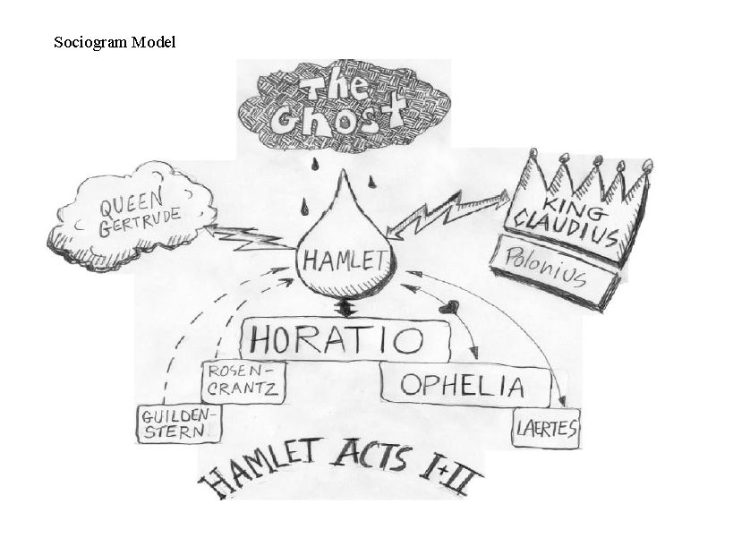

TRIAD SUMMARIZING

Students work in a triad and number off 1, 2, or 3. Each round the role will change.

ROUND | #1 | #2 | #3
A | read | summarize | Main idea
B | Significant line | read | summarize
C | summarize | Ask question related to text | read
D | read | summarize | comment
E | Important point | read | summarize
F | summarize | Most interesting point | read

