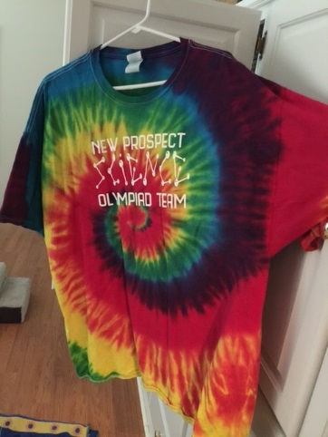
Science Olympiad Team Shirt Order
All shirts are $10 each!
Our new shirts will be the same design as last year so if you already have one there is no need to order a new one (unless you want one). Feel free to wear your shirt each Friday for sprit day! We will wear our shirts to the competition in March!

Name___________________________________________________
Homeroom Teacher___________________________________________
Circle a size:
Youth XS | Youth Small | Youth Medium | Youth Large | Adult S
Adult Medium | Adult Large | Adult Extra Large | Adult 2X Large | Adult 3X Large
Adult 4X Large | Adult 5X Large
Send exact cash amount or make check payable to New Prospect Elementary. We CAN NOT make change.
Return $ and order sheet to Ms. Welch.

Science Olympiad Team Shirt Order
All shirts are $10 each!
Our new shirts will be the same design as last year so if you already have one there is no need to order a new one (unless you want one). Feel free to wear your shirt each Friday for sprit day! We will wear our shirts to the competition in March!

Name___________________________________________________
Homeroom Teacher___________________________________________
Circle a size:
Youth XS | Youth Small | Youth Medium | Youth Large | Adult S
Adult Medium | Adult Large | Adult Extra Large | Adult 2X Large | Adult 3X Large
Adult 4X Large | Adult 5X Large
Send exact cash amount or make check payable to New Prospect Elementary. We CAN NOT make change.
Return $ and order sheet to Ms. Welch.

