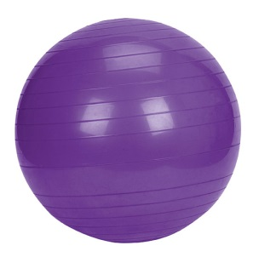
Exercise Ball Agreement

Should my child use an exercise ball?
Deciding whether or not to allow your child to replace their chair with an exercise ball is a decision only your family can make. I do not force any students to use the exercise balls, but I have seen many students become more focused and enthusiastic learners when allowed to “wiggle” while still being able to work on academics.

Research:
I have found exercise balls to be a great option for students who struggle to stay focused, on-task, and emerging research shows that students who use exercise balls have gains in concentration, on-task behavior, and show increased academic gains.
There are 3 main purposes for using the ball chairs and incorporating movement into the classroom:
- Movement increases blood flow to the brain, which is better for brain function (and learning!).
- Movement helps children "get the wiggles out" which aides their natural need to move. This helps them focus by expending the excess energy they build up throughout the day.
- Sitting on a stability ball supports and builds their core muscles which support small motor muscles (think writing and hand strength).
Choice:
I think choice is really important for students. Some days students may request to sit on a chair. I make these accommodations because I understand that sometimes students just want a break from the posture required to balance on the ball. The students have been told that this is ultimately a decision that you, as their parent, gets to make.

Rules:
- Keep your bottom on the ball.
- Keep your feet on the ground at all times.
- Little bounces only.
- Keep supplies away.
- Only touch your own ball.
- Tuck your ball in when you get up.
At the end of the day we will put our yoga balls on top of the tables with a Frisbee to hold it in place.

Consequences:
For students who fail to follow the rules, the following consequences will be used:
- Warning.
- Lose your ball for 1 hour.
- Lose your ball for a day.
- If a student continues to make poor choices, they will lose the opportunity to sit on the exercise ball.

I understand the rules for the exercise balls and agree to follow them. I understand that if I do not follow them or use my ball in an unsafe way, I may lose my opportunity to have an exercise ball for my chair.

Student Signature: ______________________________________ Date: ________
_____I agree for my child to use an exercise ball in Ms. Welch’s class Parent Signature: ___________________________

Movie clips and articles for you to find out more:
http://youtu.be/vNFaWRuWaSk
http://youtu.be/AdxduVSxUNo
http://youtu.be/86-5VfurIKk
http://youtu.be/6UGZjrSHhuA
http://www.livestrong.com/article/403541-what-are-the-benefits-of-stability-balls-in-schools/
https://docs.google.com/file/d/0B9W9zLIJ-lchNWY1MTk1NzctOTlkZi00Yzg1LTg4ZDUtNTQ2NWI1YzgwNDhk/edit
http://bigstory.ap.org/article/teachers-ditch-student-desk-chairs-yoga-balls

